REST - Get country based on country code
Write a REST service that returns a specific country based on country code. The country code should be case insensitive.
Controller: com.cognizant.spring-learn.controller.CountryController
Method Annotation: @GetMapping("/countries/{code}")
Method Name: getCountry(String code)
Method Implemetation: Invoke countryService.getCountry(code)
Service Method: com.cognizant.spring-learn.service.CountryService.getCountry(String code)
Service Method Implementation:
- Get the country code using @PathVariable
- Get country list from country.xml
- Iterate through the country list
- Make a case insensitive matching of country code and return the country.
- Lambda expression can also be used instead of iterating the country list
Implementation:

Country.java
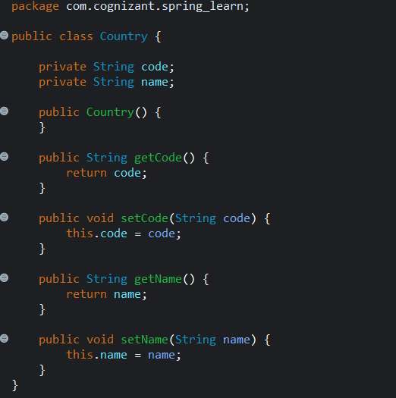

CountryService.java
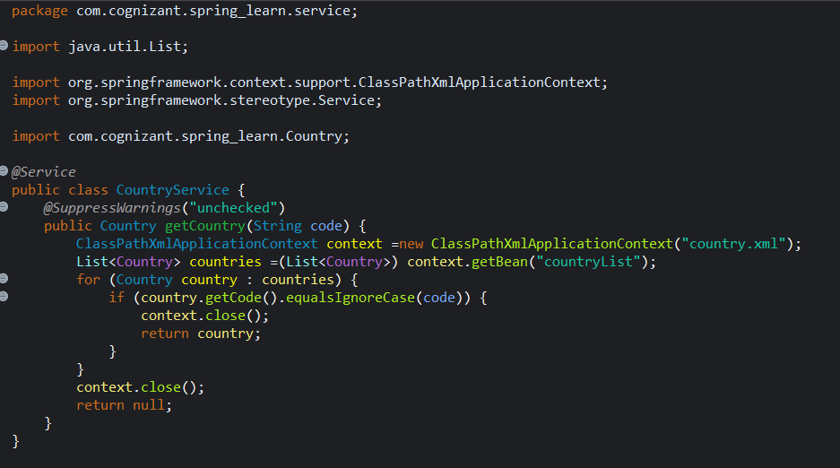

CountryController.java
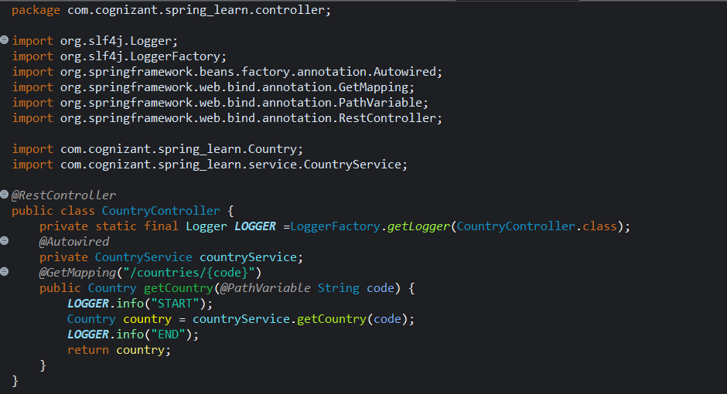

Country.xml
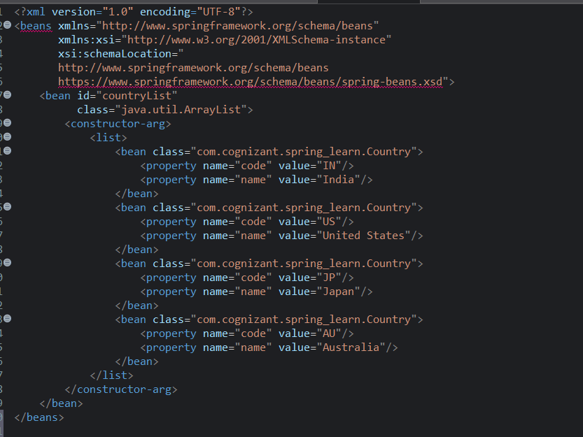
OUTPUT:
Console
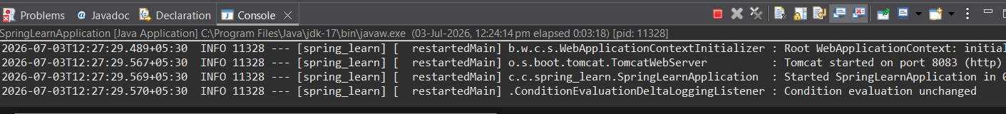

Browser
